youtube
NAME: DATE: PERIOD:

DIRECTIONS: Watch the video displayed in class, and annotate what you see in the box below. When you are done answer questions 1-6 (Front & Back). When finished, indicate which (if any) SOAPSTones you recognize in the space provided. This assignment is worth a total value of 7 Points. One for naming the SOAPSTones, six for your answers.
[SOURCE] A Video Titled "No Reservations: Brazil"
(October 15, 2012), Written and Produced by
Anthony Bourdain.

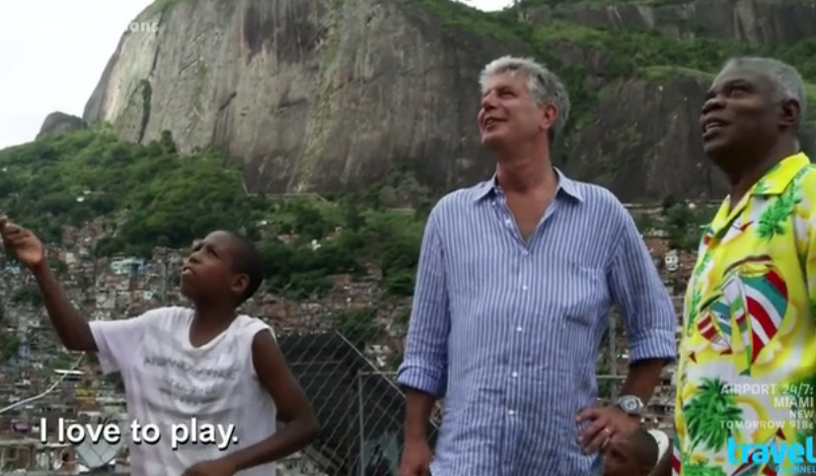


- Using a COMPLETE SENTENCE name the Title, Date, and Author of this document.

- Using a COMPLETE SENTENCE explain why this document was created.

- Using a COMPLETE SENTENCE provide a quote from the document that explains the main idea.

- Using a COMPLETE SENTENCE explain why that quote helps to
explain the main idea.

- Using a COMPLETE SENTENCE explain who would want to know the information provided in this document.

- Using a COMPLETE SENTENCE explain what the speaker wanted readers to feel after they saw this document.

S | SPEAKER: Who is the voice that is providing this document? Name the writer, speaker, artist, photographer, or any provider of the information you have.
O | OCCASION: What is the time and place this document is from? Is it from the past or the present? Where was it created?
A | AUDIENCE: Who would want to know the information provided by this document? Who do you think it was meant for? What makes you think so?
P | PURPOSE: Why was this document created? What is the reason the document's creator wanted to share this information?
S | SUBJECT: What is the main idea of this document? What it the information in this document about?
Tone | TONE: What did the SPEAKER of the document expect the AUDIENCE to feel after reading or seeing it? What emotional response was supposed to be created?

